|  |  |  |  |  |  |
| --- | --- | --- | --- | --- | --- |
| Date | 9-Dec-22 | | | Tester Name | Mohammad Yusuf |
| Environment | Penfax - Test | | | Login used |  |
| Operating System | Windows | Version: | Update: | | |
| Software Used | Select Software | Version: | Update: | | |
| Select Software | Version: | Update: | | |
| Release version |  | | | | |
| Title |  | | | | |
| Test Type | Regression | | | | |
| Test Scenario |  | | | | |
|  |  | | | | |
| Expected Results |  | | | | |
| Pass/Fail | Select | | | JIRA# | N/A |

Describe your steps with screenshots:

|  |
| --- |
| in PENFAX5 do a search for the member Click on the Stakeholder ID |
| Click on DC Benefit Selection Click ADD |
| Click on next Under Allocations Click +Add |
| Fund select a fund Contribuiton Allocation Select one fo the options Allocation Method change to % Percent enter 100 Transfer vehicle select RPP Click Save |
| Click next on the train Input a Payment Instruction(make sure to select Qualified Financial Instituion) Input a Tax Instrucion Click Submit for Approval |
| Hit Approve When the new box opens hit save |
| Wait for overnight batch processes to run |
| Go to the Communcaitons Tab Make sure under outbound documents there is a confirmation of payment letter |
| Go to Tax slips.  Make sure there is no T4A for this transaction |
| Go to the Investment Tab.  Make sure the balance is now at 0 and the account is closed |
| Go to Member Profile.  Membership status should be updated to terminated |

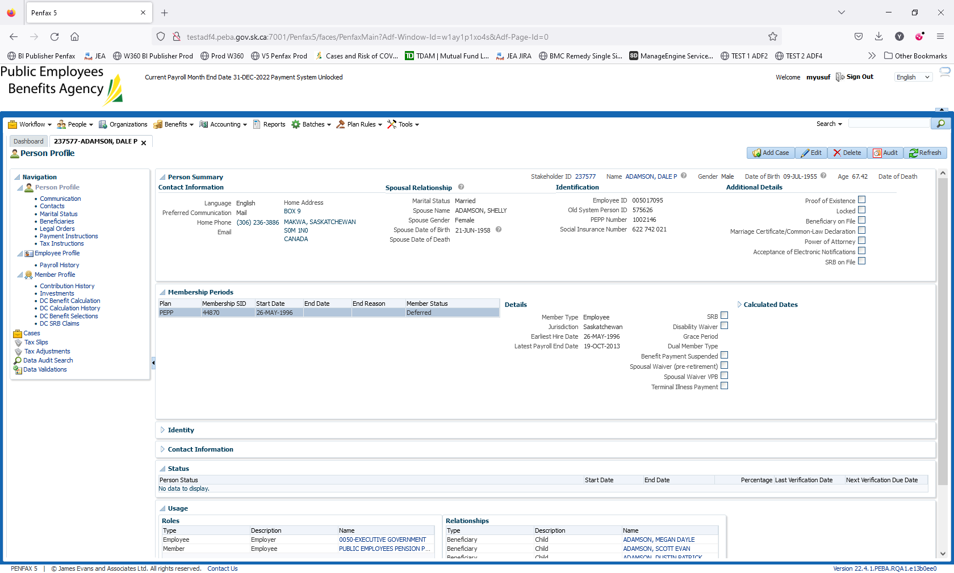

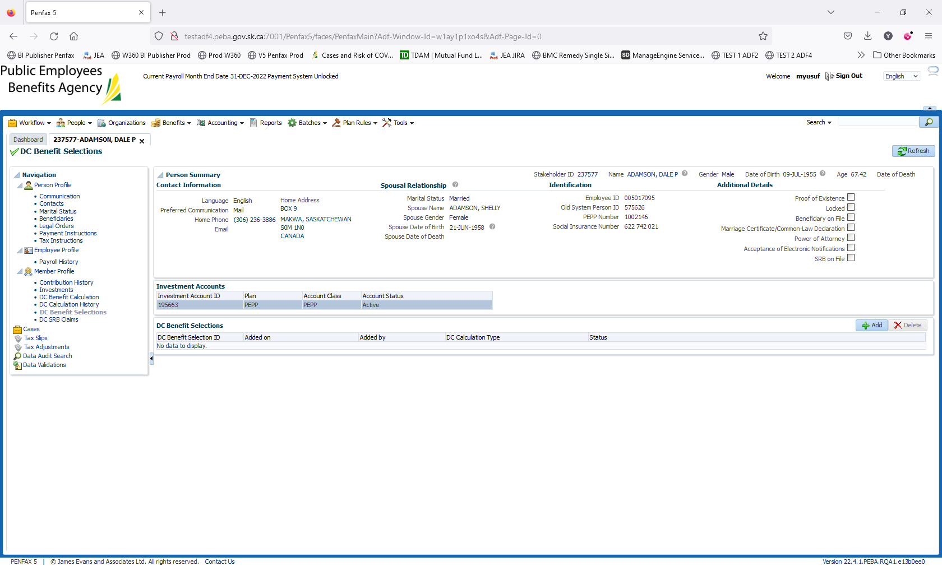

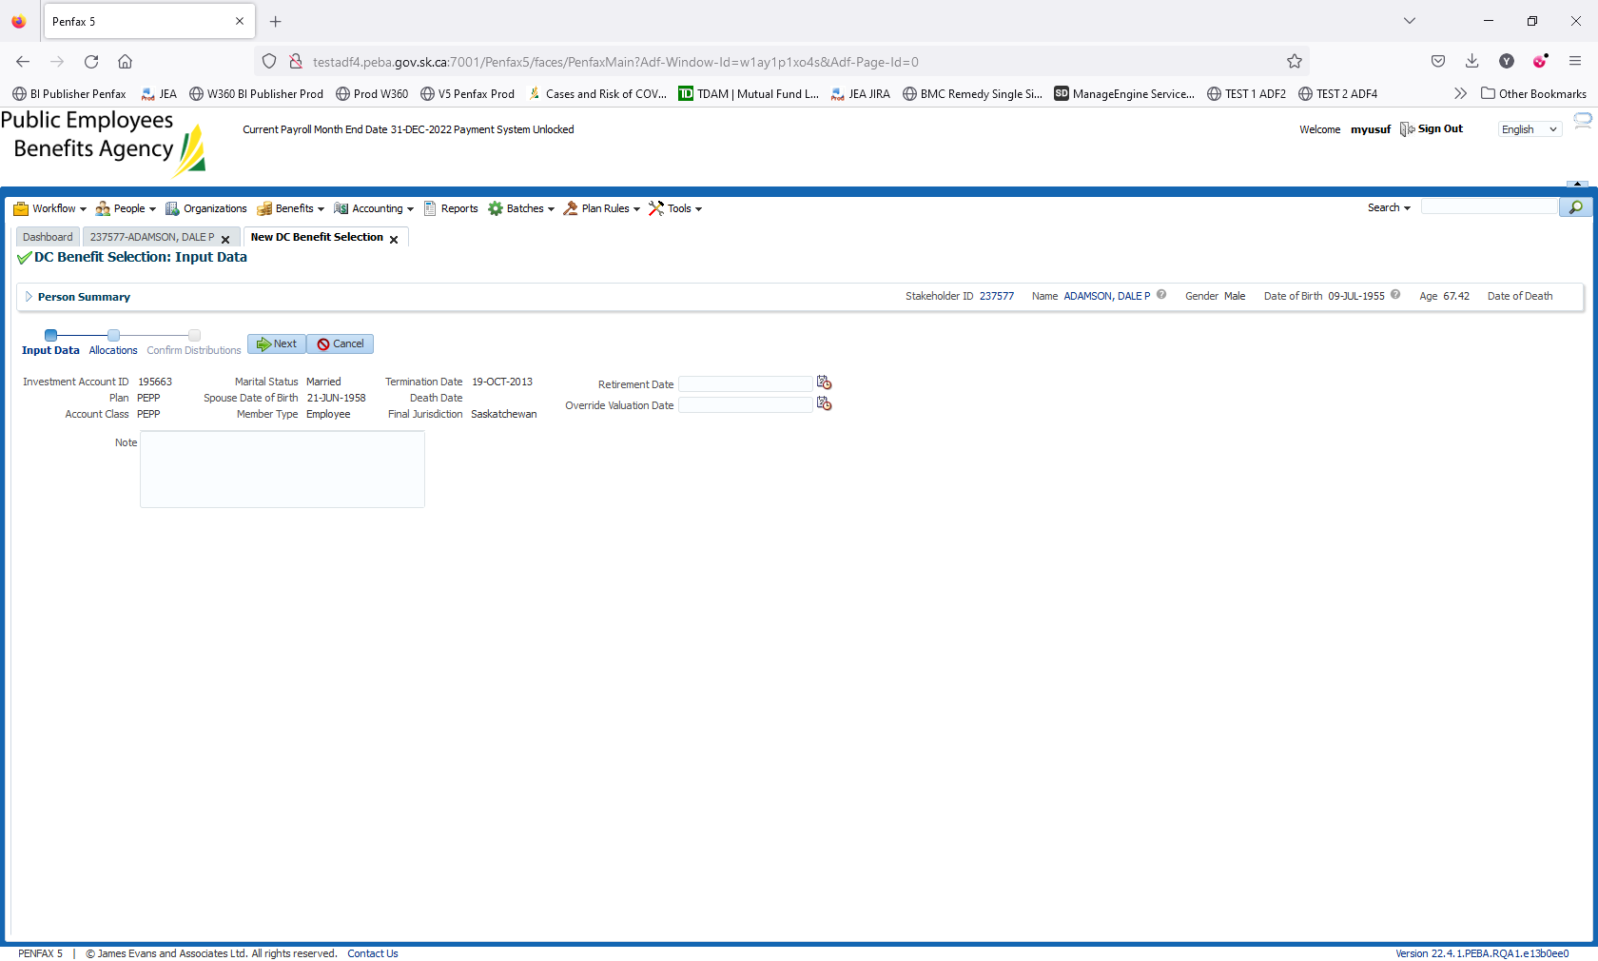

Add the retirement date

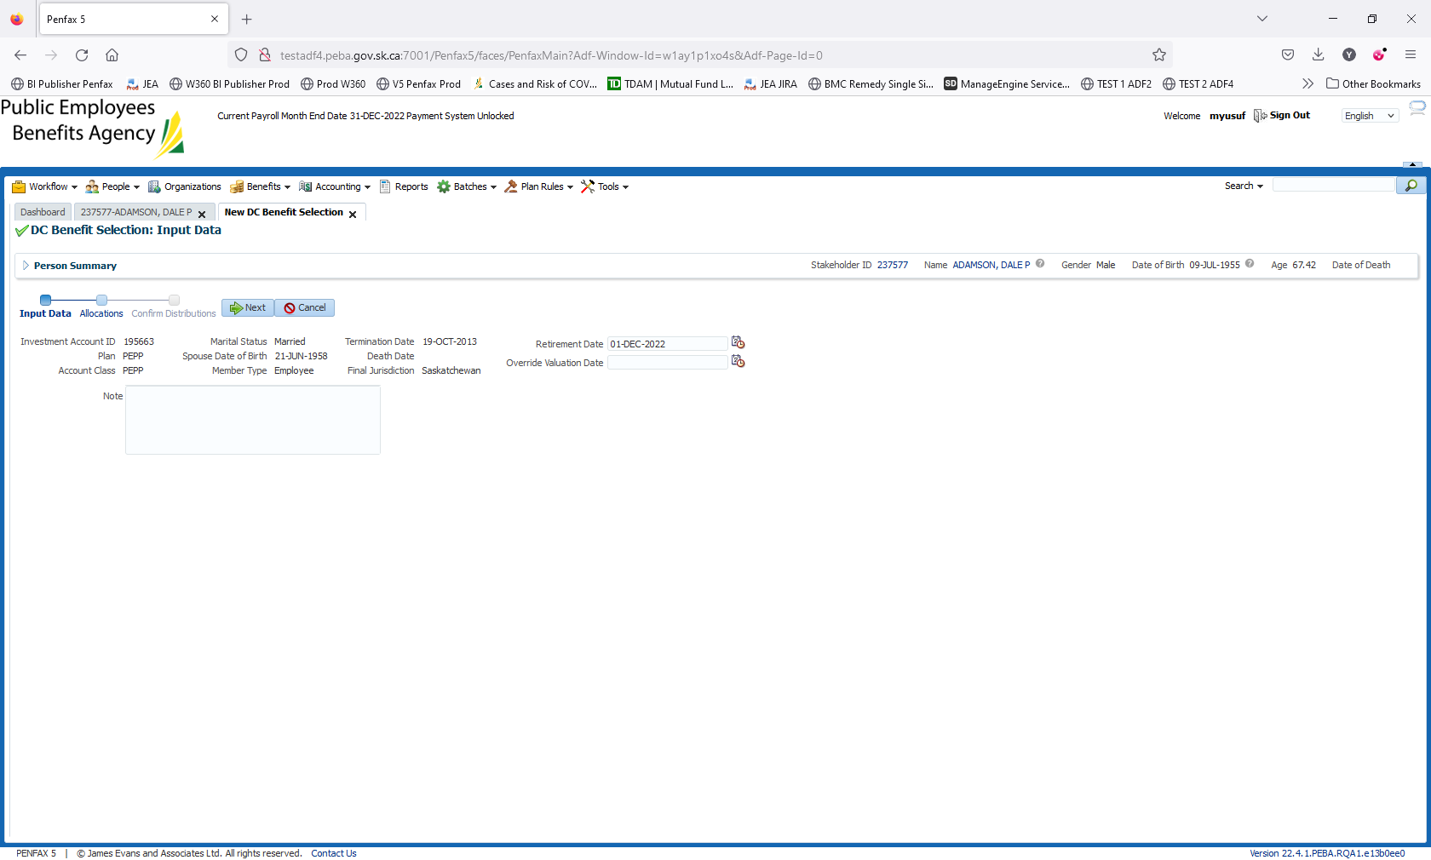

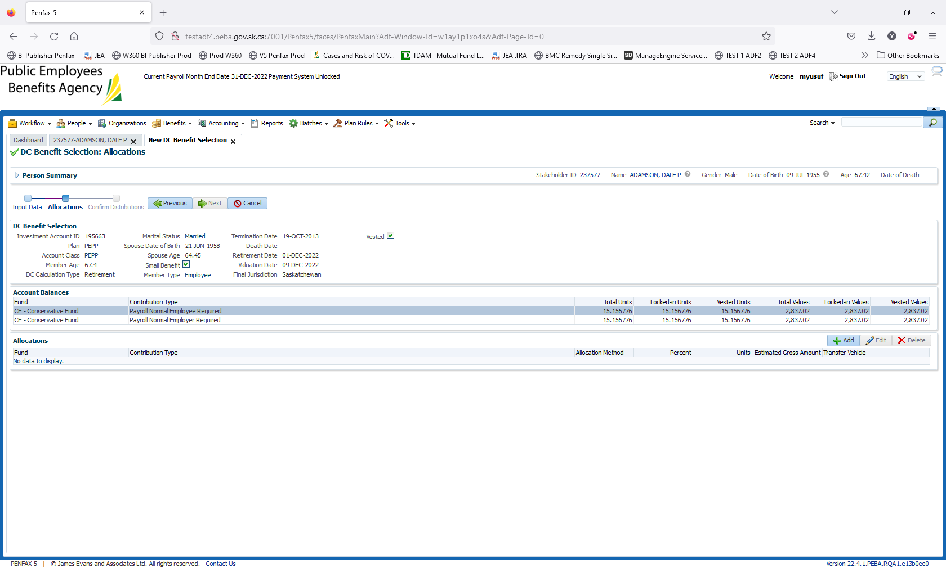

Add the allocations to RPP

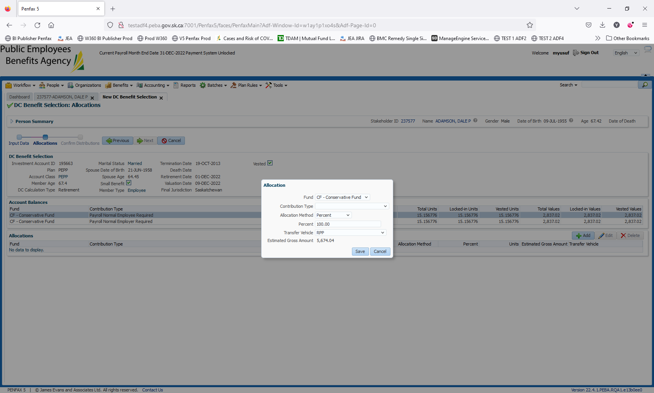

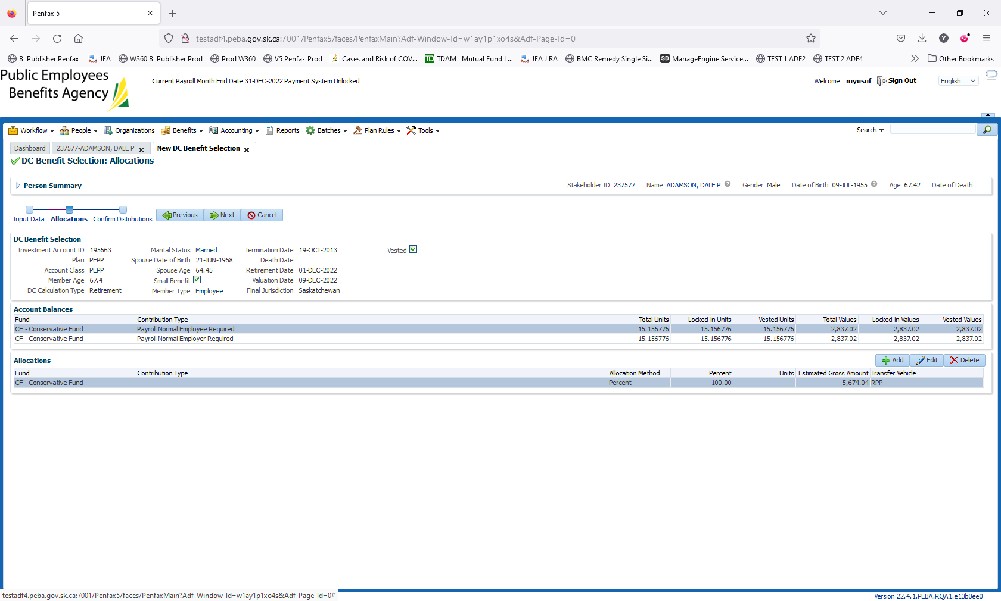

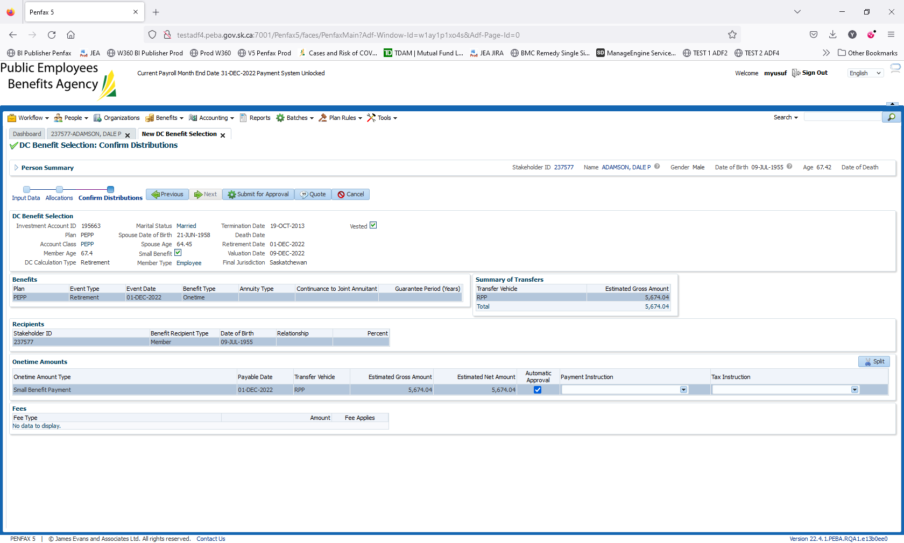

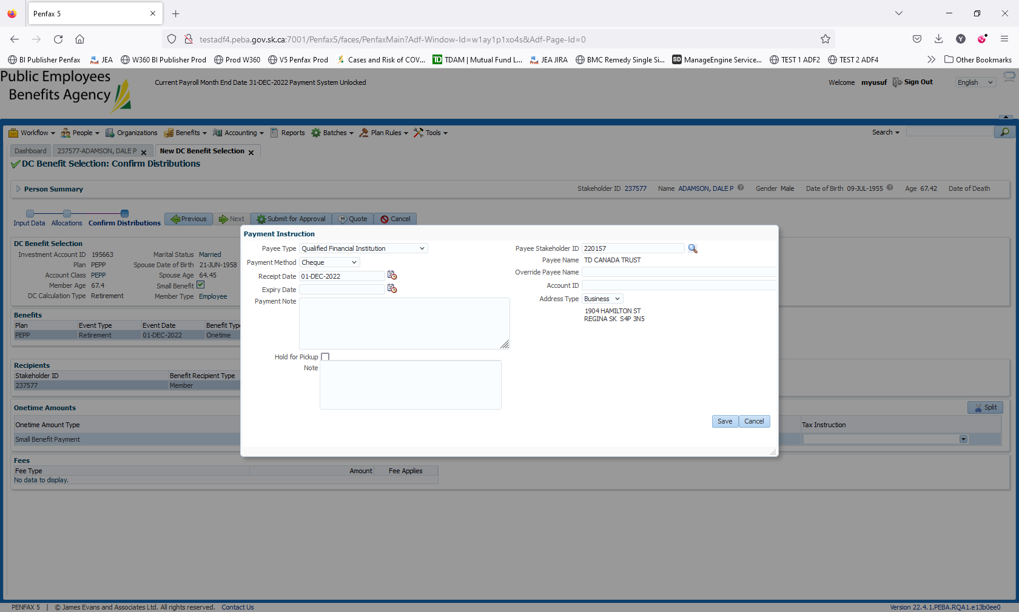

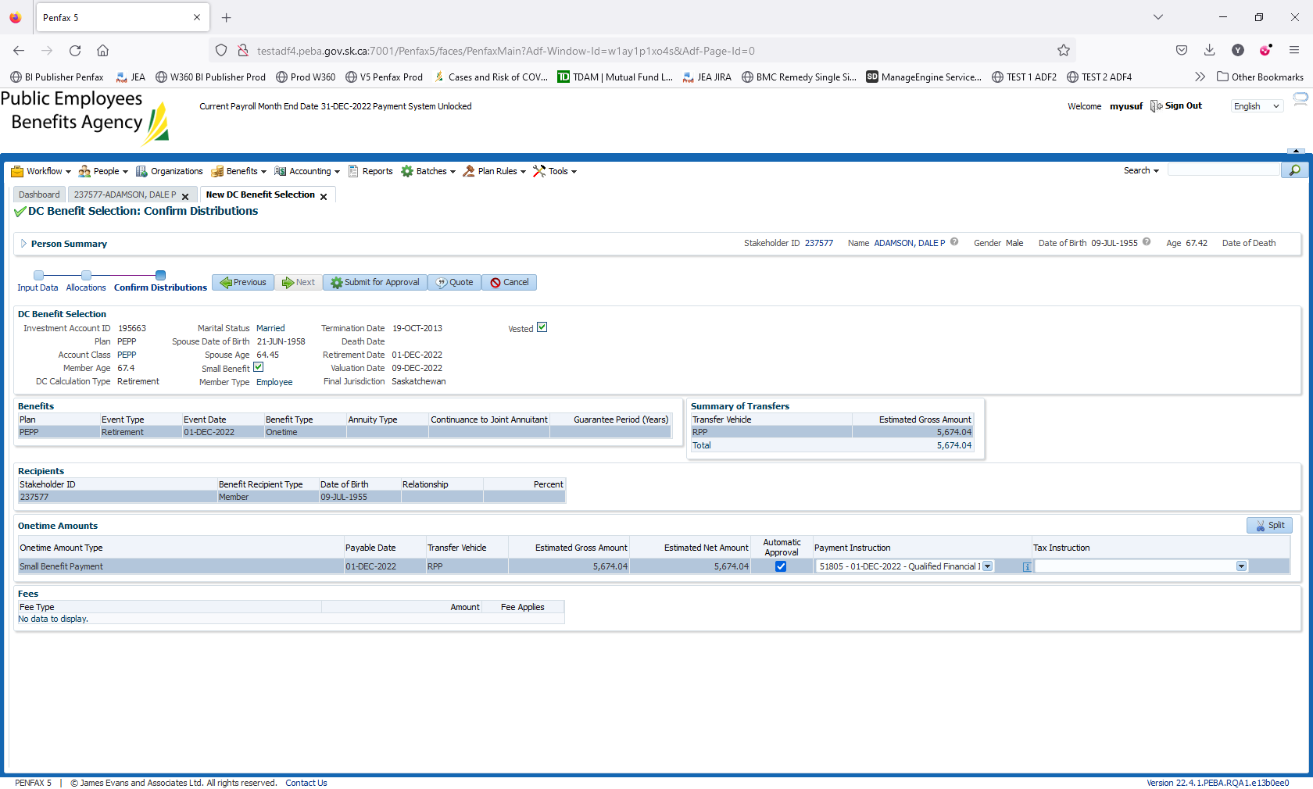

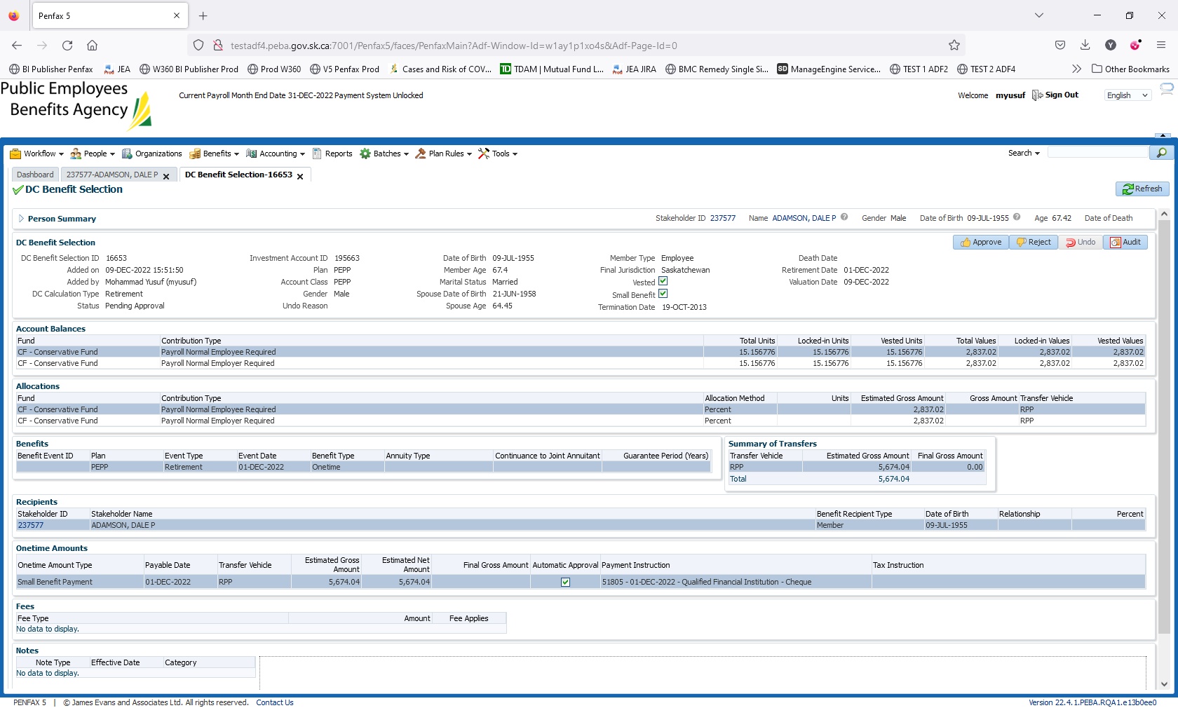

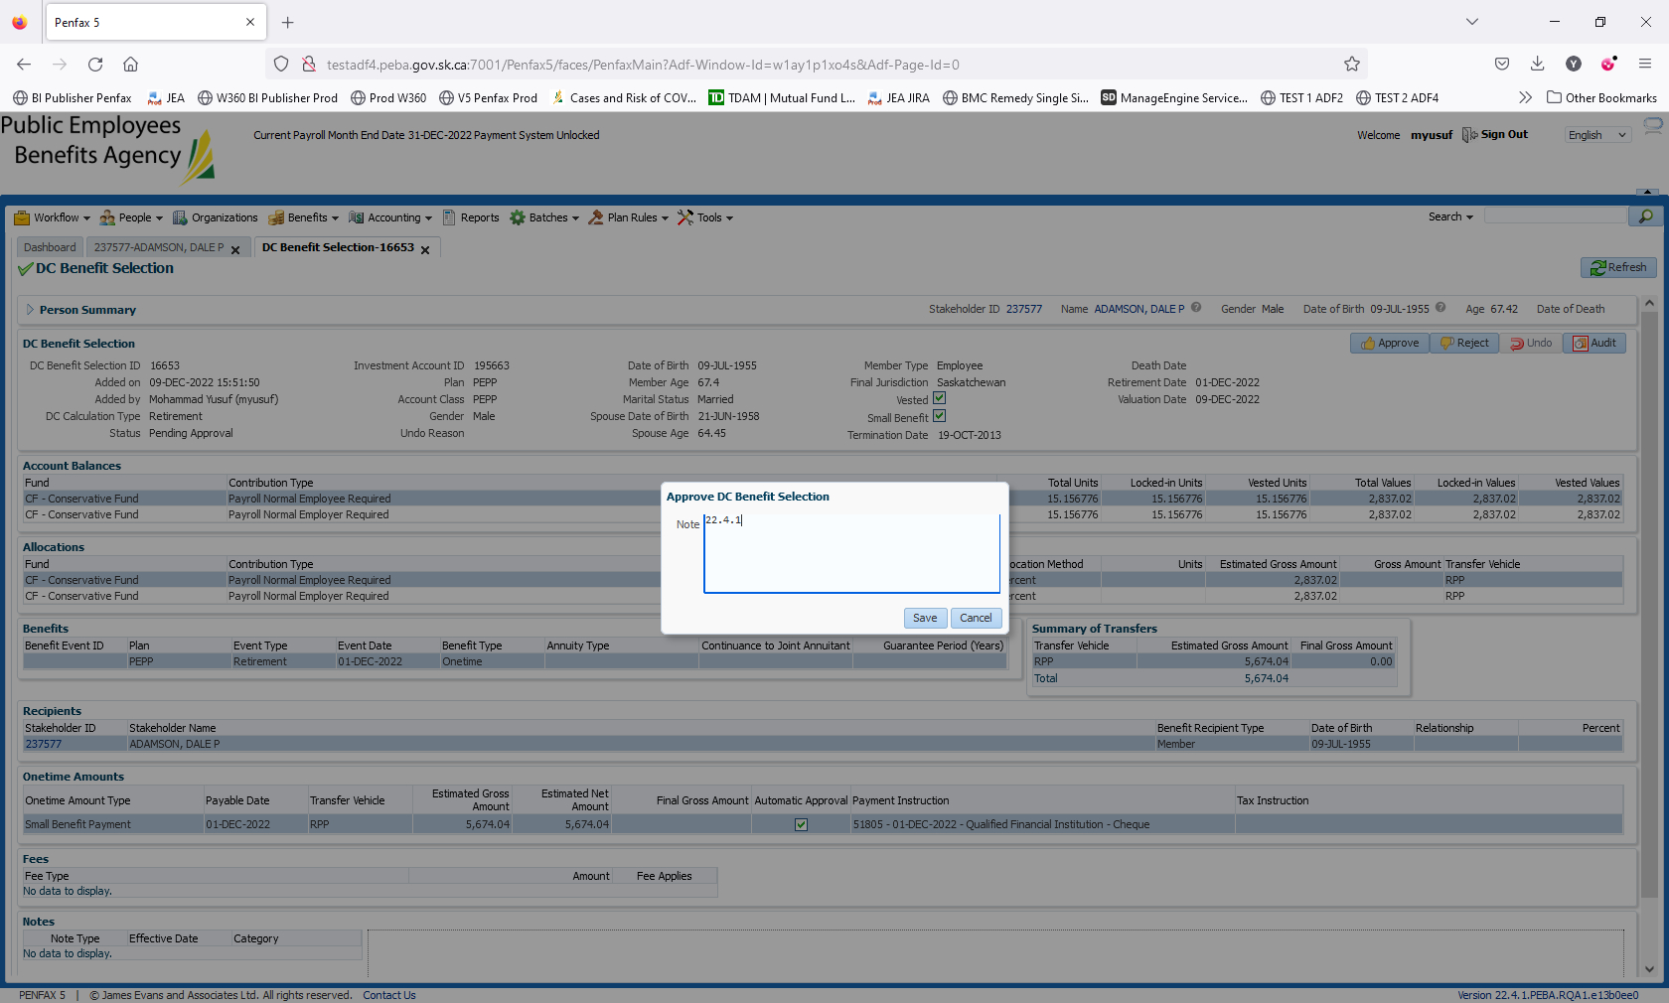

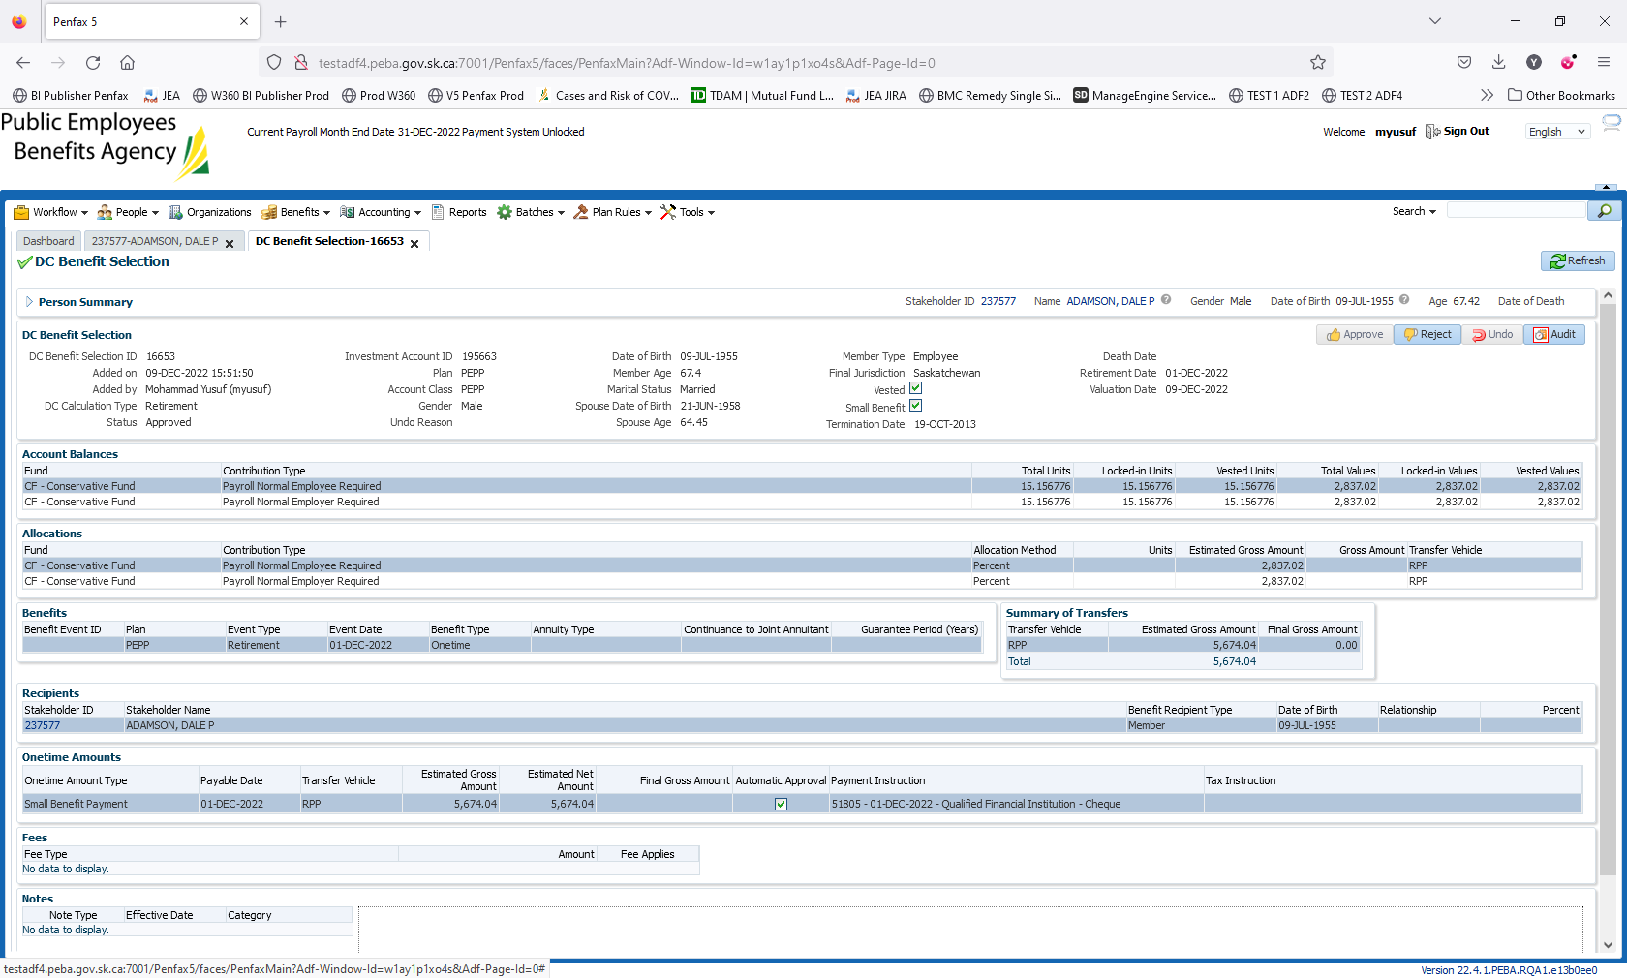

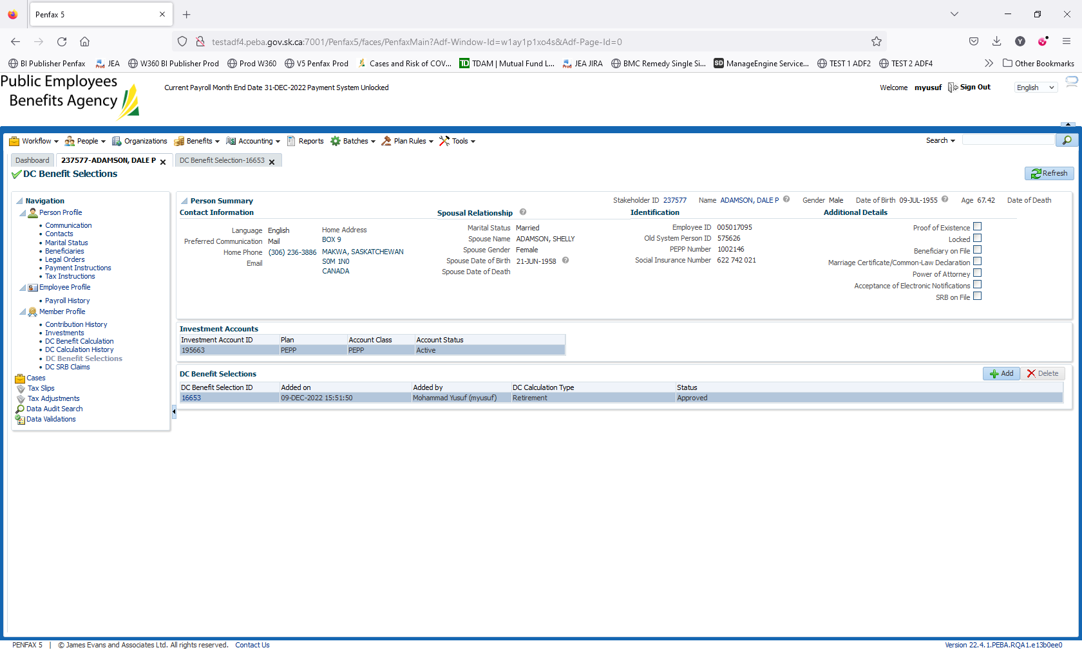

Day 2 Validation:

